API Security

🔐 What is API Security
# Source: AI Source: Provided by: [Data Path: Persons Table -> ID Column: 1, Name_En Column: Motasem Essam] -> From: [ChatGPT] on [1/19/2026]
API Security refers to the measures and best practices used to protect APIs from unauthorized access, attacks, or misuse. Since APIs expose backend systems and data, security is critical for maintaining confidentiality, integrity, and availability.
👉 Think of API Security as a lock and shield around your backend services, making sure only trusted clients can access them safely.

🔑 Key Principles of API Security
# Source: AI Source: Provided by: [Data Path: Persons Table -> ID Column: 1, Name_En Column: Motasem Essam] -> From: [ChatGPT] on [1/19/2026]
- Authentication – Verify the identity of the client
- Authorization – Control what authenticated clients can access
- Encryption – Protect data in transit using HTTPS / TLS
- Rate Limiting & Throttling – Prevent abuse and denial-of-service attacks
- Input Validation & Sanitization – Prevent injection attacks and malicious data
- Logging & Monitoring – Detect suspicious activities

🧱 Common API Security Methods

1️⃣ API Keys
# Source: AI Source: Provided by: [Data Path: Persons Table -> ID Column: 1, Name_En Column: Motasem Essam] -> From: [ChatGPT] on [1/19/2026]
- Simple token provided to clients for authentication
- Sent via headers or query parameters
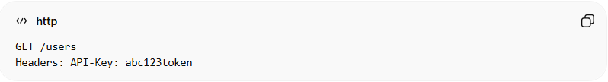
GET /users
Headers: API-Key: abc123token

2️⃣ OAuth 2.0
# Source: AI Source: Provided by: [Data Path: Persons Table -> ID Column: 1, Name_En Column: Motasem Essam] -> From: [ChatGPT] on [1/19/2026]
- Token-based authorization standard
- Supports access delegation and scopes
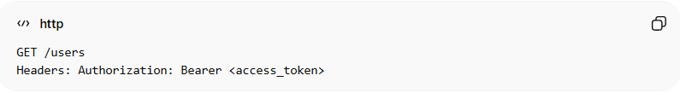
GET /users
Headers: Authorization: Bearer <access_token>

3️⃣ JWT (JSON Web Tokens)
# Source: AI Source: Provided by: [Data Path: Persons Table -> ID Column: 1, Name_En Column: Motasem Essam] -> From: [ChatGPT] on [1/19/2026]
- Self-contained tokens carrying user info
- Used for stateless authentication
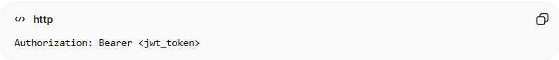
Authorization: Bearer <jwt_token>

4️⃣ HTTPS / TLS
# Source: AI Source: Provided by: [Data Path: Persons Table -> ID Column: 1, Name_En Column: Motasem Essam] -> From: [ChatGPT] on [1/19/2026]
- Encrypt all API traffic to prevent eavesdropping or tampering

5️⃣ IP Whitelisting
# Source: AI Source: Provided by: [Data Path: Persons Table -> ID Column: 1, Name_En Column: Motasem Essam] -> From: [ChatGPT] on [1/19/2026]
- Allow only trusted IP addresses to access API endpoints

🧱 Example: Secure API Call with OAuth 2.0
# Source: AI Source: Provided by: [Data Path: Persons Table -> ID Column: 1, Name_En Column: Motasem Essam] -> From: [ChatGPT] on [1/19/2026]
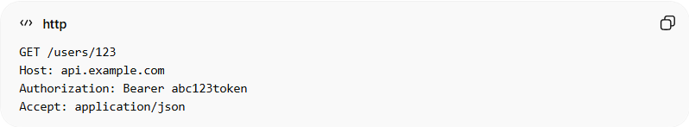
GET /users/123
Host: api.example.com
Authorization: Bearer abc123token
Accept: application/json
Response:
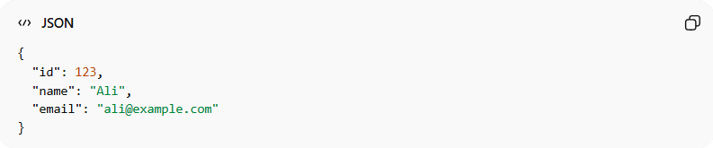
{
"id": 123,
"name": "Ali",
"email": "ali@example.com"
}
✅ Only clients with a valid token can access the resource

✅ Best Practices
# Source: AI Source: Provided by: [Data Path: Persons Table -> ID Column: 1, Name_En Column: Motasem Essam] -> From: [ChatGPT] on [1/19/2026]
- Always use HTTPS
- Never expose secret keys in client-side code
- Implement role-based access control (RBAC)
- Rotate and expire tokens and keys regularly
- Use rate limiting to protect against abuse

❌ Common Mistakes
# Source: AI Source: Provided by: [Data Path: Persons Table -> ID Column: 1, Name_En Column: Motasem Essam] -> From: [ChatGPT] on [1/19/2026]
- Using HTTP instead of HTTPS ❌
- Hardcoding secrets or credentials in code ❌
- Returning sensitive data in error messages ❌
- Not validating input or access permissions ❌

💡 Summary
# Source: AI Source: Provided by: [Data Path: Persons Table -> ID Column: 1, Name_En Column: Motasem Essam] -> From: [ChatGPT] on [1/19/2026]
API Security ensures that only authorized clients can access your API, sensitive data is protected, and the system is safeguarded from attacks and misuse.

